AResume: A Web-Based Resume Generator With Augmented Reality Features

Mary Chew Jia Yi   
*Information Technology Department*  
*University Malaysia of Computer Science and Engineering*Cyberjaya, Malaysia  
jiayi1172@gmail.com

line 1: 4th Given Name Surname  
line 2: *dept. name of organization*  
*(of Affiliation)*  
line 3: *name of organization   
(of Affiliation)*line 4: City, Country  
line 5: email address or ORCIDline 1: 2nd Given Name Surname  
line 2: *dept. name of organization   
(of Affiliation)*  
line 3: *name of organization   
(of Affiliation)*line 4: City, Country  
line 5: email address or ORCID

line 1: 5th Given Name Surname  
line 2: *dept. name of organization   
(of Affiliation)*  
line 3: *name of organization   
(of Affiliation)*line 4: City, Country  
line 5: email address or ORCIDline 1: 3rd Given Name Surname  
line 2: *dept. name of organization   
(of Affiliation)*  
line 3: *name of organization   
(of Affiliation)*line 4: City, Country  
line 5: email address or ORCID

line 1: 6th Given Name Surname  
line 2: *dept. name of organization   
(of Affiliation)*  
line 3: *name of organization   
(of Affiliation)*line 4: City, Country  
line 5: email address or ORCID

Resume is an important tool for job seekers when it comes to job hunting. With a professional resume, it might help them to secure a job. This project is intended to develop a web-based resume generator alongside with augmented reality features, known as AResume. The web-based application built is a typical resume generator that generates resume with augmented medias. It is built for job applicants who have difficulty in creating a professional resume from scratch, as well as trying to attempt “one-size-fits-all” approach, which fits all information in a resume. A web augmented reality (AR) will be developed over mobile AR because of its lightweight approach, cross-platform support and no installation is necessary. The methodology of this project is Rapid Application Development, which it rapids the development process and allows bugs fixing to be done in parallel with the development. In this project, PHP, jQuery and Bootstrap are used in web development. In addition to that, AR.js and A-Frame are the main web AR frameworks employed in this project as they are easy to be used and can enrich the experience of augmented reality among job applicants and hiring managers. The generated resume is embedded with QR code and AR markers. The QR code is scanned with QR code scanner using smartphone and it directs users to the AR scanner website. Users are able to move the scanner from marker to marker to view different contents (video, photo and documents). Hence, by using AResume, not only it will enable job applicants to create resume, upload digital medias as augmented features and scan the resume by using web browser, but also provides better user experience for hiring managers when reviewing resumes.

Keywords—Augmented Reality, resume, web development, marker-based, job application

# Introduction

A resume, or résumé is an essential tool to present one’s background, skill sets and accomplishments for job applications. However, when it comes to resume screening, an employer or a recruiter normally takes on average 8 to 10 seconds to screen resumes before shortlisting candidates for pre-screening interviews. Hence, an impressive and well-written professional resume is important to make a good first impression to potential employers [1]. Nevertheless, resume writing is a challenge for fresh graduates and most of them tend to make mistakes [2], ending up producing a poorly-formatted and unprofessional resume. Moreover, some job seekers who have broad portfolios with numerous achievements, certifications, and project details would want to attempt the “one-size-fits-all” approach, which resulted in a lengthy resume.

With the advent of the Web, an easier way for building resumes is using the existing online resume generator such as NovoResume and Rezumizer. This project intended to enhance the existing systems and user experience by proposing a web-based resume generator with augmented reality (AR) features, known as AResume. It is for job applicants who have difficulty in creating a professional resume from scratch, as well as trying to attempt a “one-size-fits-all” approach. The unique feature of this web-based application compared with others is the capability to upload digital media as AR features in order to highlight their achievements, certifications, and other important information. AR is a technology that creates an interactive experience and displays 2D or 3D computer-generated perceptual information that overlays in the real-world environment.

A web AR is implemented in this project instead of mobile AR as it is lightweight, support cross-platform and does not require installation. Moreover, the performance of rendering AR features can be leveraged by offloading the application’s computational tasks into the cloud. In this project, React.js is used as the front-end framework, whereas Node.js is used as the back-end. In addition to that, AR.js and A-Frame are the main web AR frameworks employed, and Amazon Web Service is the cloud service platform used for offloading the application into the cloud. AResume is expected to provide better user experience not only for applicants but also for hiring managers when screening resumes.

# Literature review

AR provides users with a sensory experience beyond reality by seamlessly integrating virtual contents with the real world. AR evolves historically from the year of 1996 till today that emerges the dedicated AR devices and powerful development kits as well as improves the performance of mobile devices and sensor integration and advances in computer vision (CV) technologies. AR has brought benefits to such fields like entertainment, advertisement, education, navigation and maintenance. Pokemon Go, a location-based AR game has been popular till now since its public release in 2016. Web AR is the latest technology nowadays and is gradually emerging as a promising direction for mobile AR (Qiao et al., 2019).

There are two dominant platforms for mobile Augmented Reality (mobile AR) for applications which are hardware-based and app-based. The current mobile AR hardware and operating systems that comprise of Embedded Linux, Android and iOS present a complex diversity. The advances in mobile devices, including computing and display platforms provide more choices for the implementation of AR applications.

Mobile AR has different implementation mechanisms with computing, networking and storage as the main complexities. The mechanisms are the sensor-based, vision-based and hybrid tracking methods. Sensor-based method is a lightweight approach where mobile devices support sensors like accelerometers, gyroscopes, compasses, magnetometers and GPS. The vision-based mechanism is where the camera provides the basis for vision based object recognition, detection and tracking which supports both marker-based and markerless methods. Marker-based method uses a predefined marker to meet the tracking requirement whereas markerless method detects and understands an unknown or outdoor real-world environment. It is currently using SLAM and collaborates it with other sensors to face the obstacle of computational inefficiency and limitations of the resources of mobile devices. Hybrid tracking mechanism combines different methods that increase the complexities of networking, storage and computational compared to the other mentioned mechanisms.

However, there are some downsides of mobile AR. The hardware-based implementation is costly and lacks of flexibility whereas the app-based requires additional downloading and installation. Most of its applications and solutions are designed based on a specific platform which causes the inconvenience for cross-platform deployment. To reach more users, an AR application needs to go through repeated development cycles to accommodate different platform which undoubtedly increases the cost of development and deployment [3].

The birth of web Augmented Reality (web AR) is known to be the future promising direction for mobile AR. It is because of its lightweight, native cross-platform features and pervasive service provisioning of mobile AR. Thanks to the invention of the World Wide Web (WWW), it makes the web AR possible. The idea of using web in the technology of AR is that the web simplifies the service access for users, for example Facebook and Snapchat which they are designed in a hybrid way (native + web) way that provides a good interaction experience and cross-platform support.

However, there are some challenges when AR meets the web in real life. Compared to mobile AR, web AR has the limited computing and rendering capability that causes the degradation of the performance of web AR. It also hinders the fiducial tracking method that provides an accurate and robust tracking approach for web AR applications. Markerless mobile AR implementation is to be ported to the web. Another challenge of web AR is network delay. When web AR application is deployed into the cloud server, there are large communication delays, due to the limited data rate and unacceptable network delay which causes the difficulty for current mobile networks to support real-time operations like tracking and interaction.

Besides, web AR is a power-hungry application which is due to limited battery capability. The need for the sensors to cooperate over a long period of time, the analysis of the information, computing, communication and display puts tremendous pressure on the battery of the mobile device. Hence, the extreme energy consumption hinders the deployment of web AR. In addition, diverse enabling infrastructures also cause a compatibility challenge in terms of display platforms, operating systems and data formats. Besides, it is also challenging the development of web AR when it comes to supporting different sensor, display platforms and OS. The virtual contents crated by different tools also causes compatibility issue.

Regardless of the issues mentioned, there are two approached solutions that can solve the issues. Both limited computing capability and limited battery capability can be solved by offloading computation-intensive tasks to the remote cloud. It will accelerate the performance for web AR applications. Since they are dependent on mobile networks, the “browser + cloud” approach causes high latency and communication delays. It happens when getting data from the cloud server. But it can be solved by the 5G network, the upcoming advanced network technology in the future that provides higher bandwidth (0.1 – 1 GB/s) and lower network delay (1 – 10 ms), which improves data transmission on mobile networks [3]. With the 5G network, a new paradigm which is called mobile edge computing (MEC) provides cloud computing capabilities at the edge of networks close to mobile users and greatly reduces network latency [4]. However, the deployment of web AR applications into the cloud server requires high monetary cost.

There are some existing software applications that have been developed to create resumes, business cards and the like. Some of them have integrated with the AR technology. Each of them has their own functionalities, advantages and disadvantages as well.

|  |  |  |  |
| --- | --- | --- | --- |
| Features | Image result for novoresume logo | Image result for resumizer logo |  |
| Cross-platform support | x | x | √ |
| Web AR support | x | x | √ |
| Digital media upload | √ | x | √ |
| Produce augmented contents | x | x | √ |
| Free hosting for AR apps | x | x | √ |
| Free publication for AR apps | x | x | √ |
| Marker-based support | x | x | √ |
| Generate sharable URL | √ | x | √ |
| Create augmented resume | x | x | √ |

# Requirement Analysis

## Survey Analysis

A survey has been conducted to acknowledge the opinion of the respondents regarding AResume. The number of the respondents is 50 in total.

Figure 1 below shows the importance of the contents which will be displayed with augmented reality (AR) feature in the resume. Contents that are highlighted are videos, photos, social medias, websites, certificates and transcripts. Based on the figure, the extreme importance of these contents have outnumbered the less importance and no importance. It explains that it is important to include those kinds of contents in the resume.

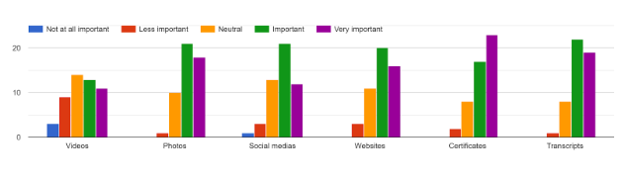

1. Importance of the contents displayed with AR

Figure 4.10 below indicates the preference for features proposed in the AResume. Such features are importing information from LinkedIn, generating sharable URL for the particular resume, creating augmented resume, exporting resume into different file formats as well as scanning the resume to view the augmented contents. Most of the respondents prefer these features.

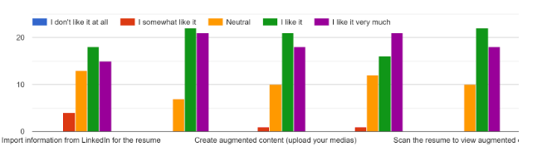

1. Preference for features in AResume

## Functional Requirements

There are some functional user requirements in AResume for job applicants that are included in this project. Such functionalities are as: Create user account, choose a resume template, build a resume, upload digital medias, view generated sharable link, scan markers on the generated resume, export resume into different file formats, download resume, edit and delete resume.

# The Proposed Application

## Architecture

Figure 3 below is the component diagram of AResume, which explains the overall system architecture of AResume. First and foremost, the user inputs the data in various format such as text, video, photos and documents for a particular resume through a web application in a browser. All the data will be stored in the database. The web application and database is hosted with 000webhost that provides free web hosting. Through the web application, the user is able to view information of the resume.

Video, photos and documents are all embedded into the AR marker. The user opens the QR code scanner using a smartphone and scan the QR code that embeds an URL which directs the user to the AR scanner website. Then, the user scans the markers on the resume and the contents (video, photos and documents) uploaded by the user will be able to see the contents as AR features in the phone. The user can move the scanner from marker to marker to view different contents.

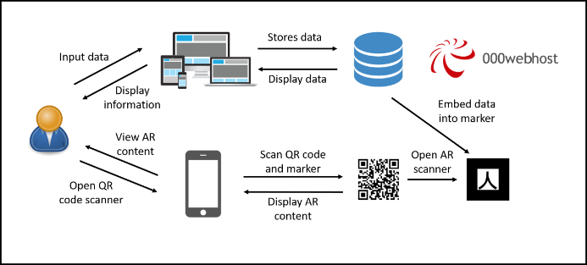

1. AResume system architecture

## User Interface

Figure 4 below shows GUI of the website. Users provide input about their personal information and can upload a video if they have any. The content of the video can be the self-introduction of the user and other relatable information. Those who involve in creative arts, video is a great way to showcase their artworks. The video is optional. There is a resume completion progress bar to show the completion progress.

1. User interface of website (profile section)

Figure 5 below shows an online resume with generated URL. When a resume is generated, a URL or link is generated for the particular resume. It is to allow users to share the URL of their resume and send it to the other people or hiring manager. In each resume, there is one QR code and a few AR markers. The QR code is embedded with AR scanner website URL which requires users to open the QR code scanner using their smartphone. Each AR marker on the resume stores different contents of different sections.

1. Online resume with generated URL

Figure 6 below shows the scanning process to open the AR scanner URL. Find the QR code in the resume and open the QR code scanner of the smartphone to scan the QR code. It directs users to the AR scanner website and an instruction of how to scan the markers in the resume appears in an alert box. For the first-time users who scan the resume, users are prompted to allow the camera permission.

1. The scanning process

Figure 7 below shows the AR output display on the smartphone. When the AR scanner detects one of the markers, the AR content appears. When it is not detected, the content disappears.

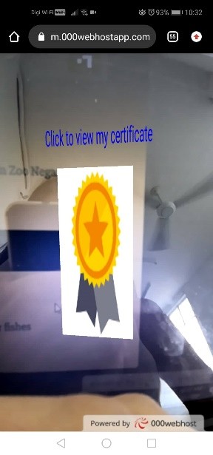

1. Sample AR output display on smartphone

# Conclusion

This project summarizes that a resume generator is built alongside with web AR feature. This project allows users which are job applicants to create a resume for job hunting easily. Besides, web AR is implemented in this project. They will be able to upload any digital medias such as videos, documents and pictures that act as augmented medias when they scan the markers on the resume. The markers are where all the augmented medias are placed. Without the need to install any mobile applications, they will have the chance to enrich their experience with AR by just scanning a QR code which directs them to the web browser and scan the resume. The development technologies have been identified to develop the application in both web development and augmented reality as well as the rough-sketched diagrams of this application for a clear understanding of how it works. System testing and user acceptance testing were carried out to ensure the quality of the application. The intention of this project is to lessen burdens of job applicants when creating a resume and to enrich the AR experiences for users, especially hiring managers who view it.

##### References

1. J. Roo, "The Importance of a Well Written Professional Resume | Roo Resumes," 27 April 2015. [Online]. Available: https://www.linkedin.com/pulse/importance-well-written-professional-resume-roo-resumes-judi-roo/.
2. Z. Mustafa, "Writing a resume: Art of your ownself," 7 November 2018. [Online]. Available: https://www.nst.com.my/education/2018/11/429011/writing-resume-art-your-ownself.
3. Qiao, X., Ren, P., Dustdar, S., Liu, L., Ma, H., & Chen, J. (2019). Web AR: A Promising Future for Mobile Augmented Reality-State of the Art, Challenges, and Insights. *Proceedings of the IEEE*, *107*(4), 651–666. https://doi.org/10.1109/JPROC.2019.2895105
4. Qiao, X., Ren, P., Dustdar, S., & Chen, J. (2018). A New Era for Web AR with Mobile Edge Computing. *IEEE Internet Computing*, *22*(4), 46–55. <https://doi.org/10.1109/MIC.2018.043051464>